Assignment 2: Least Squares

Implementation: I wrote the classifier in Python, making use of the csv, math, numpy, and random libraries to handle data easier.

Data and Interpretation: To test the classifier, I ran it for 1000 trials twice for lambda values of 0.0-1.0 for each percentage of the data as training (10, 30, and 50). For each trial, the same training data was used for each value of lambda. The resulting percent error is was documented for each case and I graphed the resulting averages below. For each graph, the x-axis is the lambda value and the y-axis is the percent error. The blue is the training set and the red is the test set.

From these graphs, we can see that as the percentage of training data increased, the percent error decreased, with 50 percent training having a low error of around 17-18 percent. More interesting to look at is the value of lambda and how it effects the error. I did not run tests for lambda greater than 1 as the upward trends in the graphs tend to continue until they start to converge at a much higher percentage. In all of the runs, as lambda increased, the error in the training set increased, which is to be expected as using any lambda should increase the error as no lambda corresponds to optimizing the error function. In each case, though, varying lambda tended to have about the same effect. Initially, increasing lambda corresponds to a more accurate predictor in the test cases. This is true up until about 0.1, at which point increasing lambda tends to start increasing the error in the test cases. This trend is especially clear in the 10 percent training case and becomes less and less as the training percentage increases. This makes sense because the classifier should work better the more test cases it is given. When there are few test cases, there is going to be more deviation in them and so the classifier will be influenced by extreme values a lot more. Also, in a lot of cases, the number of each class in the training set can be quite skewed. Adding a regularizer serves to counter this influence. As the number of training data is increased, the regularizer becomes less important.

Interesting to note is this algorithm's performance when compared with the Naive Bayes classifier. In this case, the Naiver Bayes classifier performed much better than least squares. I think this has a lot to do with how the data is structured. It attributes are very descriptive about the data set. Thus, Naive Bayes works well because in general, objects of each class will always fall in the right “bin”. There are a few collisions, though, but Naive Bayes is better at avoiding them. The least squares classifier tends to get more confused at these fringe cases because it will put the same amount of weight on each characteristics, whereas Naive Bayes doesn't put as much weight on characteristics that aren't as discriminating. Finally, the least squares classifier does better as the number of training cases increases. Naive Bayes shows this tendency as well, to a point.

10 percent: Run 1 10 percent: Run 2
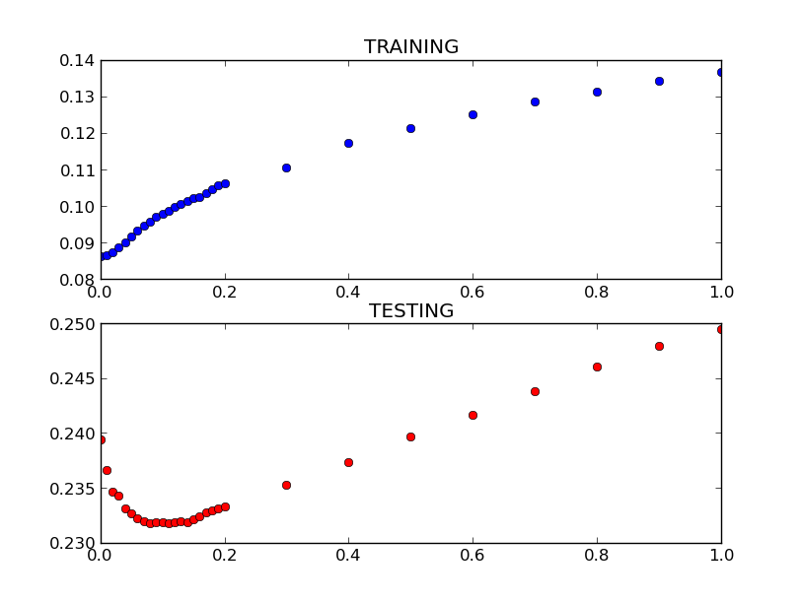
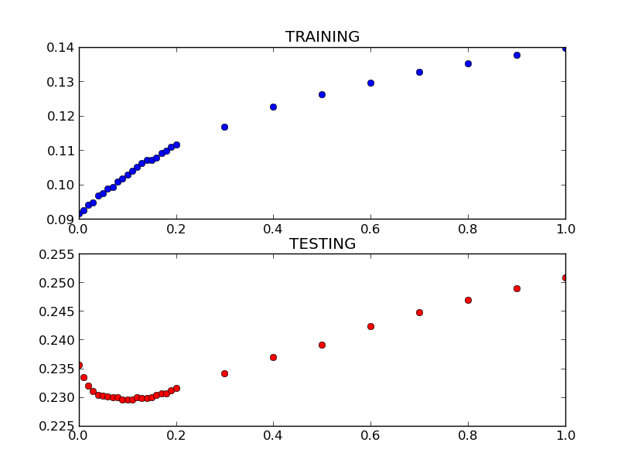

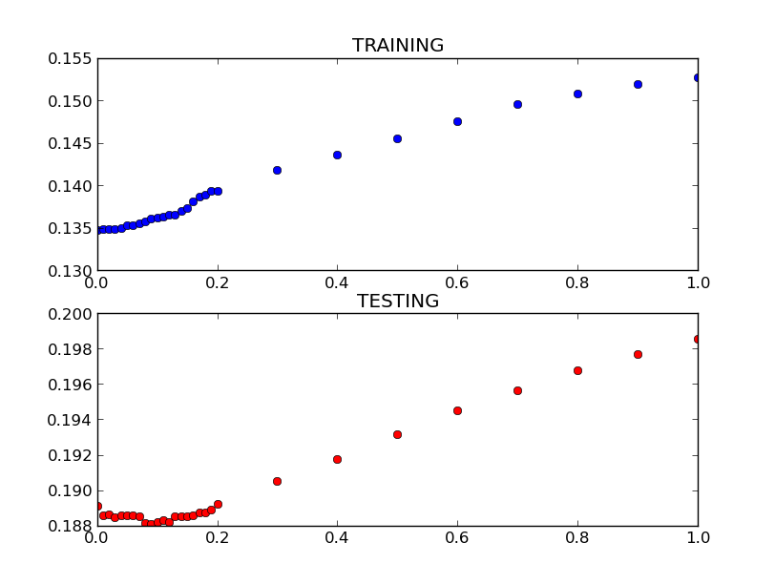

30 percent: Run 1 30 percent: Run 2
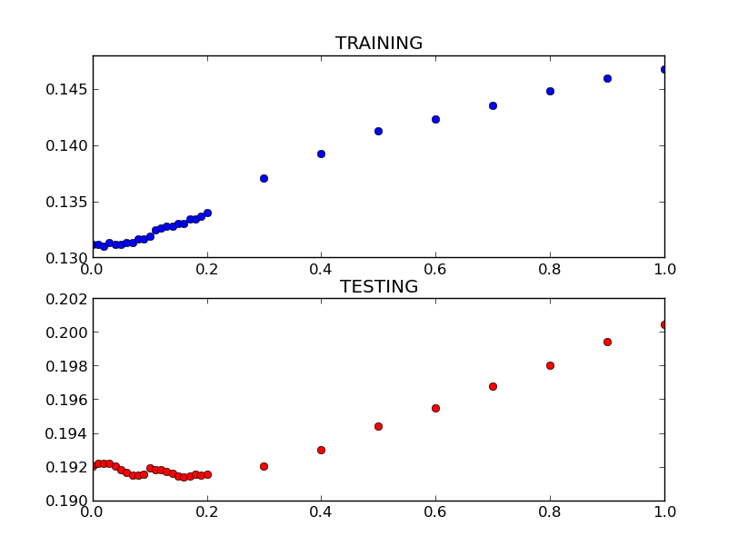

50 percent: Run 1 50 percent: Run 2
